Annotation Symbol Guide

Symbol | What It Means
# (1, 2, 3, 4, etc.) | Paragraphs and Stanzas
Underline | Key word/ Details
Double Underline | Main/Central Idea
* | Important Information
 | Vocabulary
? | Confusing
! | Surprising
Notes in margin | Thoughts and Comments
+ and - | Agree or Disagree
 | Visualization
∞ | Connection
E | Evidence
 | Characterization
 | Figurative Language
 | Motif
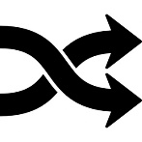 | Change in character or setting
 | Symbol

